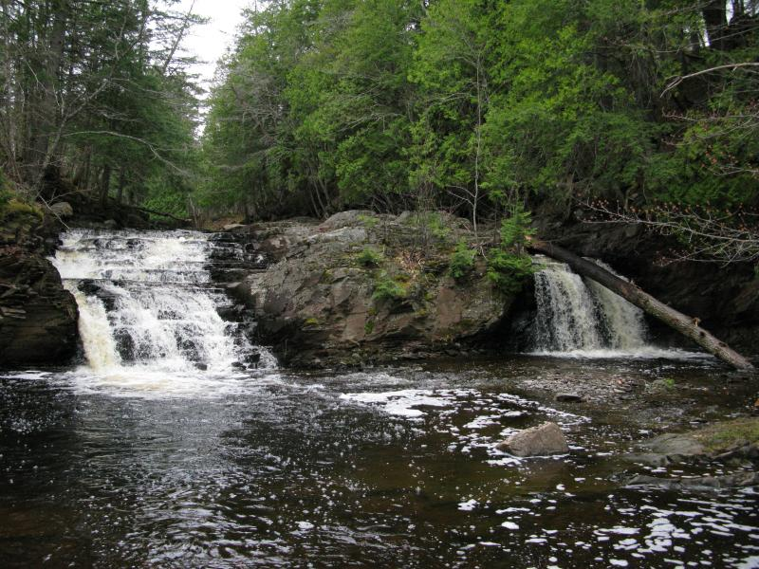

Remote and difficult to reach, Big Falls is a large split drop over tiered slate. The drops are about equal in size and flow (except during dry spells, when the left side dwindles down to a small chute) and are split by an outcropping large enough to support several small trees. Above the main waterfall are some short stepping drops crossing the river while downstream is mostly a calm, gravel-based river. Tall pines line the sides of the water and a steep western wall, with the access road on top, fences in the river.
Big Falls is the uppermost waterfall on East Branch Huron River, a few calm miles upstream of a jumbled slate gorge. While not as rugged as Slate River or the West Branch's waterway, this gorge still holds a number of waterfalls, which exit the gorge on the north end.
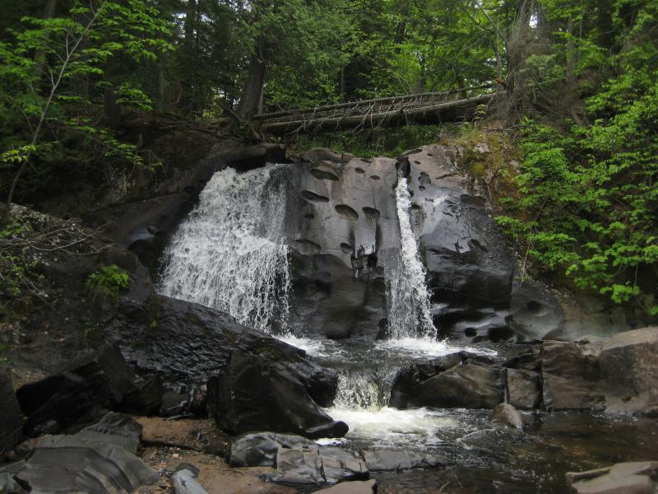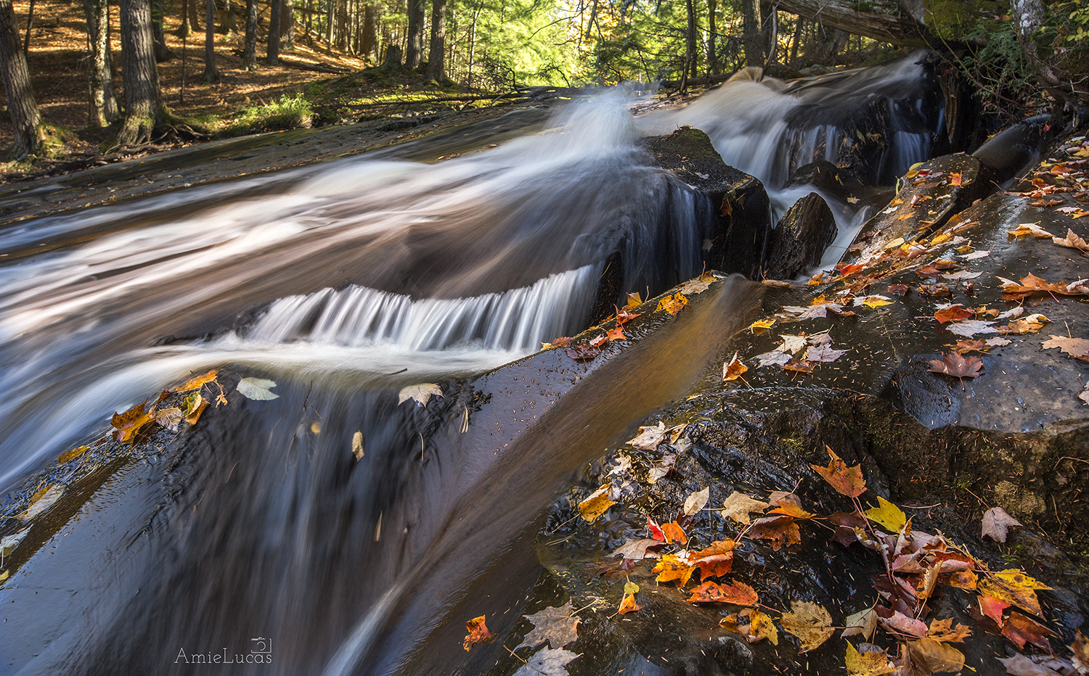

Leatherby Falls (also known as Middle Leatherby Falls) is a rather interesting drop far up in the highlands near Mount Arvon. It’s made up of three parts; Upper, Middle, and Lower. The lower falls are pretty but not much more than a couple of small drops. It’s nothing special, especially in comparison to the rest of the waterfall. The Middle Leatherby waterfall is a two-tiered drop over a sharp rise of basalt surrounded by cedars. The lower half is a blocky set of cascades that forces the river to the side before it tumbles down over the small chunks. The upper half, though, is an entirely different setup. Water pours down a few worn cuts over a deeply pitted wall, fanning over the smooth portions and catching on the curious pits.

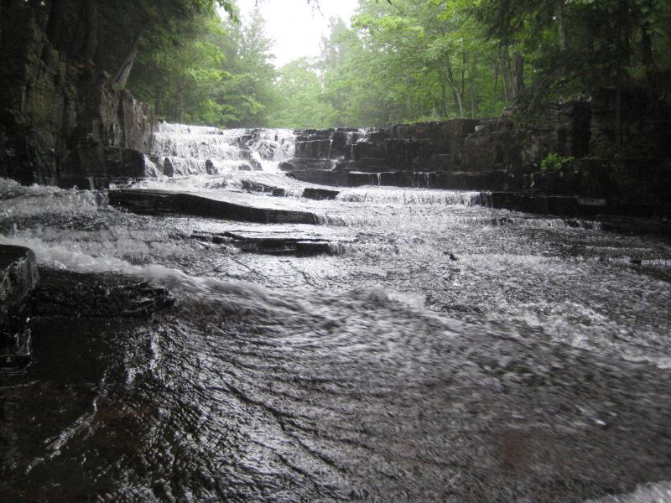
Quartzite Falls is a perfect little waterfall high above the rugged gorge on Slate River. The river drops in a sudden crescent onto a large, flat slide of slate before flowing into a deep pool surrounded by cedars. Quartzite Falls may be small, but its shape and scenic area makes for an amazing waterfall experience. This waterfall is a short distance downstream of Black Slate Falls, an easy walking distance from the road and about a mile from the slate quarries of Arvon. This area makes for an excellent little adventure that is fairly accessible for all ages.
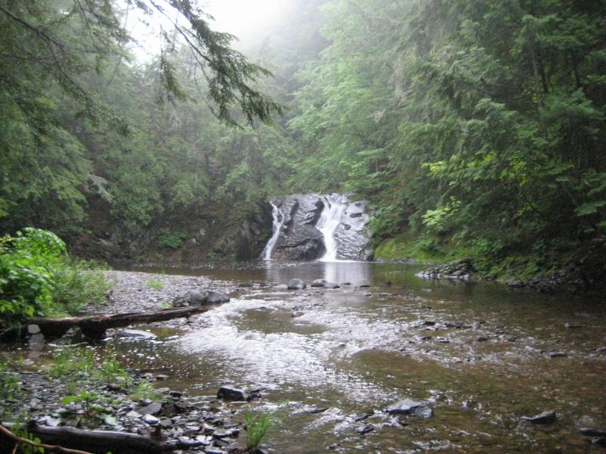
As the Slate River empties out of a deep gorge it has one final, impressive setting to flow through. Slate River Falls is an idyllic tumble into a deep pool surrounded by steep banks and towering trees. The waterfall itself is a bit odd, two angled streams of waters plunging down a layered tilt of rock, but the view is quite striking. Getting past this drop to the upstream waterfalls is a bit difficult and involves a tough climb either up the side of the falls or all the way up the east bank.

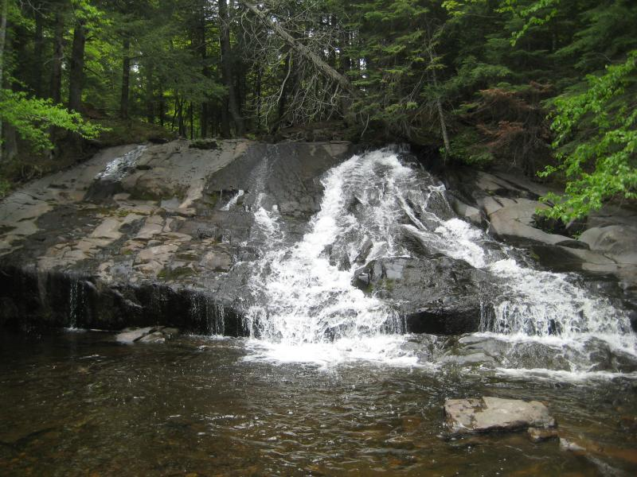
Just a few hundred yards upriver from Leatherby Falls is a wide, fanning slide that empties into a deep pool. The slide is formed from smoothed basalt (with a few dips and crags that cause the water to jump and foam up in places) that is taller than the downstream falls. Upper Leatherby Falls also marks the end of a long string of swamps near the base of Arvon and the beginning of West Branch Huron River's exciting trip down to Lake Superior. . A sliding drop, this waterfall has some pretty unique characteristics. From far away, it looks like a typical slide waterfall but as you get closer you will see several little chutes carved into the rock from the water. There are mini gorge-like passageways for the water to move through. These “gorges twisted”, turned and abruptly ended. They are incredibly smooth and very beautiful.
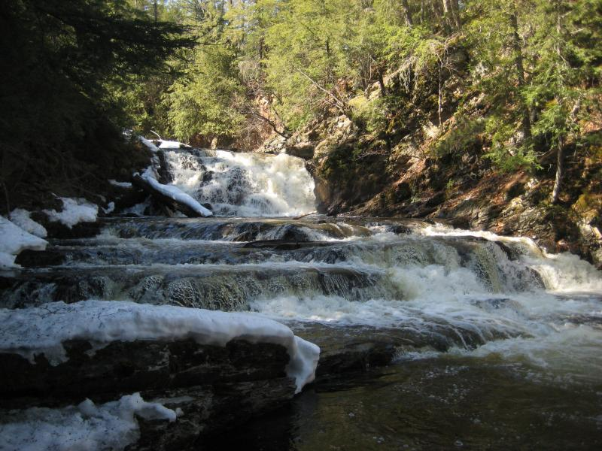
West Branch Falls on the Huron River is an impressive chain of individual drops along the river within a deep, rugged slate gorge. The main waterfall is a direct cascade that crashes upon a central outcropping, splashing to either side and creating a fine mist during heavy flow. The lower drops are mostly narrow chutes, water hemmed in by sloped rock and pouring down in a powerful stream into deep pools or over hard rocks. It is divided into 3 falls - Upper, Middle & Lower West Branch Falls. After you climb over the rocks at the lower falls, continue upstream. There are two more significant drops before the main waterfall. Even more small drops are upstream but are difficult to get to, as the main waterfall stretches across the entire gorge.
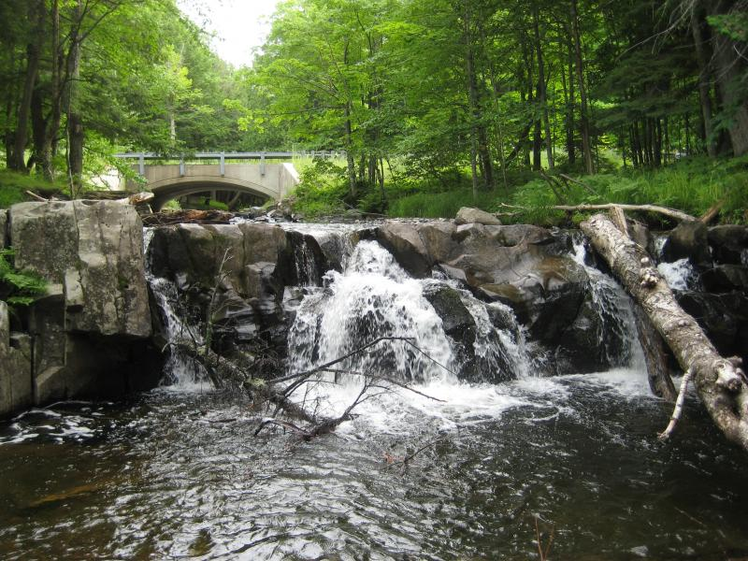
It's easy to draw some comparisons between Erick's and Big Erick's Falls. After all, they are both on the Huron River and they both have a bridge over them. Where Big Erick's Falls is a historic location with an impressive wooden bridge and DNR camping site, Erick's only has a cement bridge with a few clearings for tents. Also, Erick's Falls is much smaller, only a few narrow chutes between blocky mounds of rocks.
The main feature that makes this waterfall interesting is the area. Far up on the West Branch of Huron River, this waterfall is deep enough in the wilds to start forgetting about road signs. The trees start to get taller, elevation increases, and traffic more sparse. Erick's Falls may not be as big or as famous as its big cousin downstream, but it still makes a great destination.
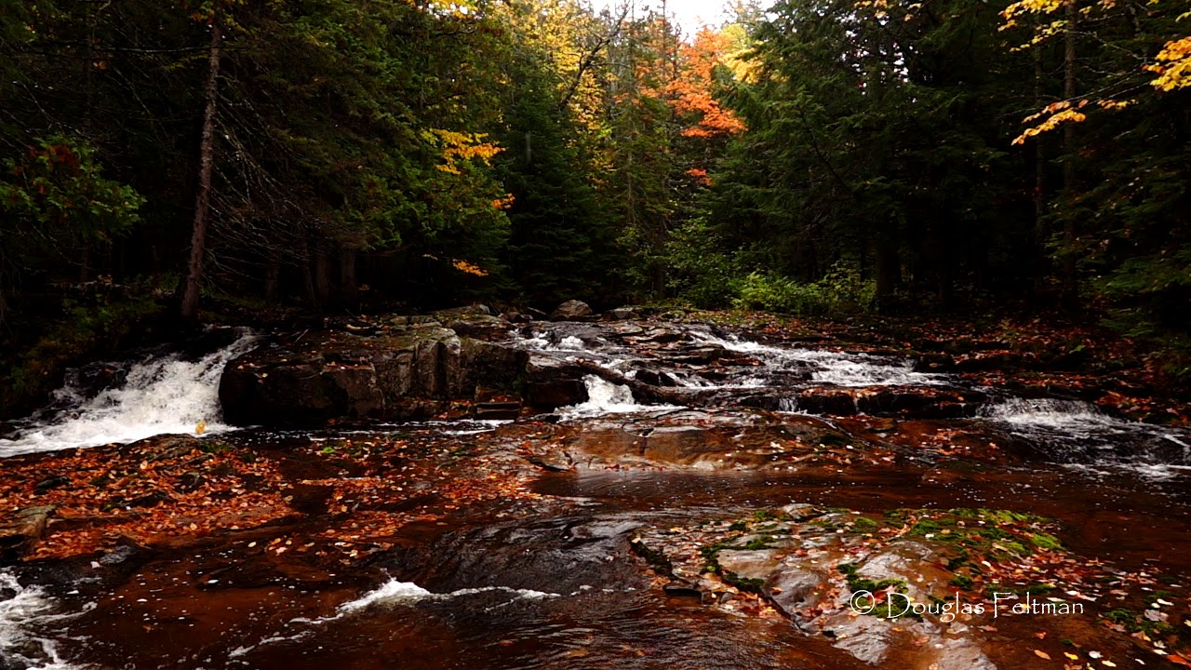
Located on the Slate River is Black Bear Falls. This dusty, brown bedrock is widened out to 100 feet at the waterfall, with the uneven mass producing several cascades across its width, gathering itself together at the base of the 5 foot waterfall. The widened river then flows over masses of brown bedrock. This far upstream the Slate River does not flow over slate, just over bedrock.

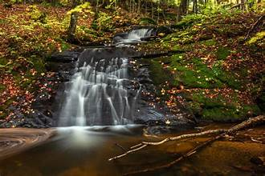
Pea Can Falls - a small tributary to the West Branch of the Huron River, there are several nice drops and beautiful slides. A short hike downstream from the Upper Cascade is the Upper Slide, a 3 ft plunge on top followed by a 9 ft slide into an elongated spill pool. This slide is mostly smooth, hard, black basalt which is fractured here & there. The third segment of this small waterfall is a 1 ft slide at the top followed by an angled slide into a 30 ft circular spill pool.

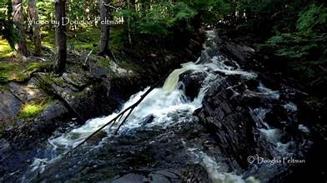
Slate Flume Falls is deep in the Baraga forest on the Slate River. It starts with a long, rock-based flume through the woods, where it makes a sharp corner to drop down to another flume, which leads to the main falls. There are abandoned slate quarry ruins nearby which show this area was once used as a mill with buildings and containment pits. With only 2 or 3 of its many waterfalls easily accessed, the Slate Flume Falls is one that requires a 4 wheeler or long hike to find. This area is where the Slate River slowly gathers more water from tributaries as it flows north to Lake Superior.
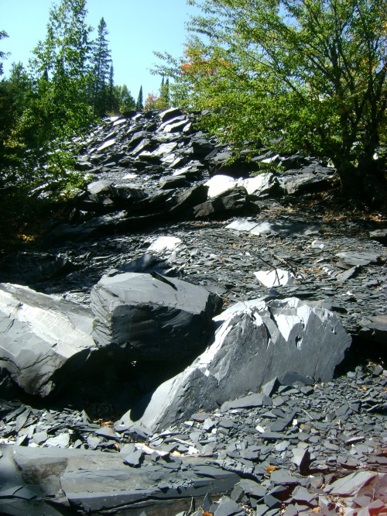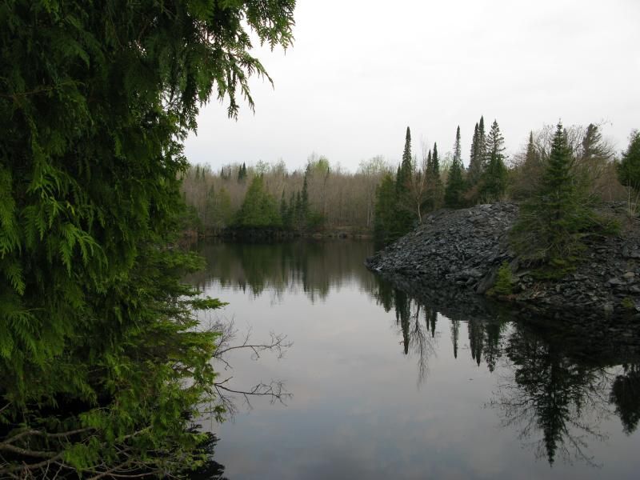
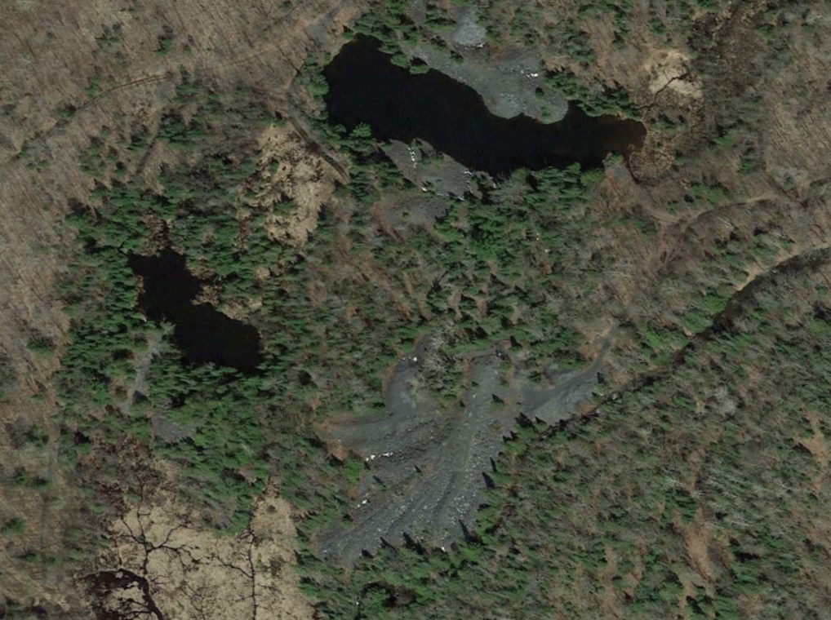
Satellite image of Huron Slate pit on right (larger one) and Clinton Slate pit on left.
The Huron Bay Quarry (better known as Arvon Quarry) pulled slate from the pits for around thirty years. The entire operation was closed down in the 1890s, right around the time that the Iron Range & Huron Bay Railroad was being built.

During the post Civil War period, slate was popular as a roofing material for large municipal and private construction projects. The supply of slate could be problematic for some areas as most commercial supplies (or what was considered the best supplies) came from Pennsylvania, Maryland, Vermont and New York. Transport of heavy slate tiles over great distances was expensive and lower cost local supplies were sought after. The slate of Baraga County was found to be of high quality equal to that of the eastern regions. There appeared to be large quantities which could satisfy demand and last for many years. Although Baraga County was quite remote, it did have at its disposal a deep water harbor with connections to the quickly growing cities of Detroit, Chicago and Cleveland to name a few.
Commercial slate mining in Baraga County Michigan began around 1872 with the formation of the Huron Bay Slate and Iron Company and the Clinton Slate Company in 1874 less than 2,00 feet to the southwest of the Huron Bay locations. According to records of the time, in 1873 when slate shipments started a 3 foot tram road was used to transport the finished slate, 4.5 miles to a 600 foot dock on Huron Bay. In 1874 the tramway was extended to serve the Clinton site. The early reports do not mention the mode of power used.
A company town was built a short distance from the mining location and named “Arvon Station”. The tram would pass through Arvon Station on its way from the mining pits to Huron Bay. Contracts for slate were quickly won with the promise of cheap shipping from the deep harbor at Huron Bay to ports around the Great Lakes. It is rumored that after the Great Chicago Fire, many rebuilding projects there used (or intended to use) slate from Baraga County. Unfortunately with the Panic of 1873, the subsequent depression and possible poor management, both enterprises were in complete ruin by the end of the decade.
In 1881 the property owned by the Huron Bay Slate and Iron Company, the Clinton Slate and Iron Company, and the Superior Slate and Mining Company (no information is available as to where or when this operation started), was purchased and re-organized as the Michigan Slate Company. The new company began work at the quarry in the fall of 1881.
The new company built a new stone engine-house with a seventy-five horse-power engine for hoisting and pumping. They also build a small saw-mill for the timber and lumber required for repairing buildings and erecting new ones. The quarry operations were updated with new tools and equipment as well. The tramway was overhauled and repaired with heavier rail and the dock was also rebuilt. All of these updates were in anticipation of new contracts from places like the new Texas State capitol building and a new University Library building at Ann Arbor.
The slate industry for Michigan never did prosper as expected. In the ANNUAL REPORT OF THE COMMISSIONER OF MINERAL STATISTICS OF THE STATE OF MICHIGAN, FOR 1884, the Michigan Slate Company is described as “gradually enlarging its operations, and continues to produce a fair amount of the very best roofing slates. As the pits are enlarged the product is increased, but the enlargement is necessarily slow, and it will take time to bring the quarries up to the maximum production of which they are capable.” The fact is that the slate business never did grow into what the investors had hoped. By the time the Iron Range and Huron Bay Railroad used the old tram roadbed for its own right-of-way the slate business had pretty much slowed to a crawl.
The coming of the IR&HB would mean the end of the slate mining in the area. The IR&HB was known as the Million Dollar railroad. That’s what it took to build and it never ran a single train. With the Panic of 1893, poor management and its chief engineer, fleeing to Mexico to escape allegations of fraud, the state eventually took possession of the right-of-way and other property as compensation for unpaid taxes. It is worth noting that one of the investors in the IR&HB was also one of the owners of the Michigan Slate Company. It appears the right-of-way and access to Huron Bay may have paid for the stock but also doomed his business once and for all.

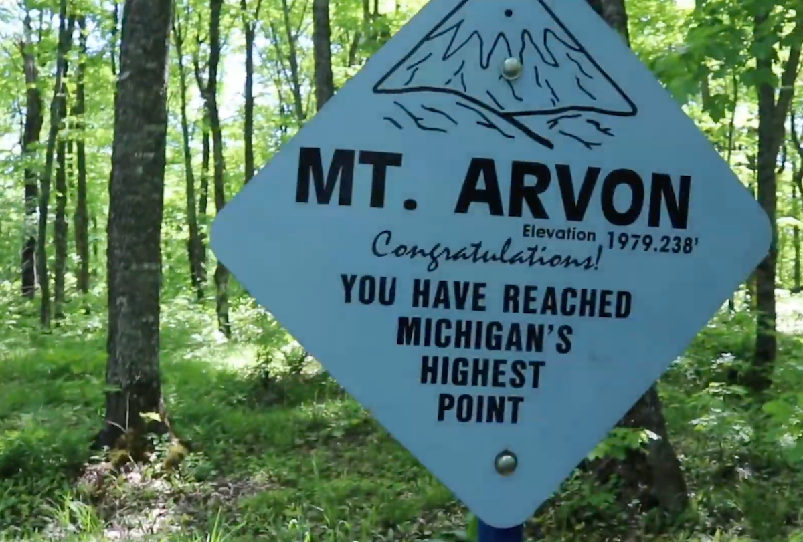
Mt Arvon - Mount Arvon is Michigan's highest natural point, standing tall in the rugged Huron Mountains. Located in Baraga County, this 1,979-foot peak offers incredible views of Lake Superior and the surrounding wilderness. Reaching the summit requires a short but challenging hike through dense forests and across rocky terrain.
Mount Arvon is the 38th highest natural point in the United States. However, it wasn’t always known as the highest point in Michigan. For about a century, starting in 1872, the area was used as a slate mine and when the slate was all mined, it became a logging operation. It wasn’t until 1982 that the U.S. Geological Survey measured it and found that it was actually 11 inches taller than what they thought was the highest point in the state.
While the discovery put Mount Arvon in the headlines, it didn’t bring droves of tourists or locals to see its summit. The maze of logging roads, unreliable directions, and remoteness have kept Mount Arvon one of Michigan’s lesser-known gems. Still, the summit is publicly accessible for both drivers and hikers.
The road up to the trailhead and summit is rocky and unpaved, but the recent regrading of the logging roads has made the drive more enjoyable though. It is not advised to try and drive up after it rains as the mud can make it impassible. The summit of Mount Arvon cannot be accessed by vehicle in the winter (white tape). The drive is best from May to October.
If you prefer to walk to the summit, it’s a 1.75-mile hike on a single track trail that climbs approximately 425 feet. Look for the frequently placed blue diamond blazes in the trees to lead the way.
At the top of Mount Arvon, you’ll find a USGS medallion, a blue diamond sign labeled “Highest Point in Michigan,” and several memorials to Eugene Ott, a veteran and local outdoorsman. There is also a bench where you can sit to observe the landscape below.
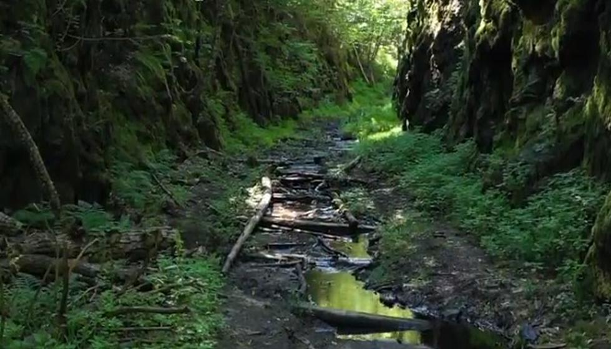
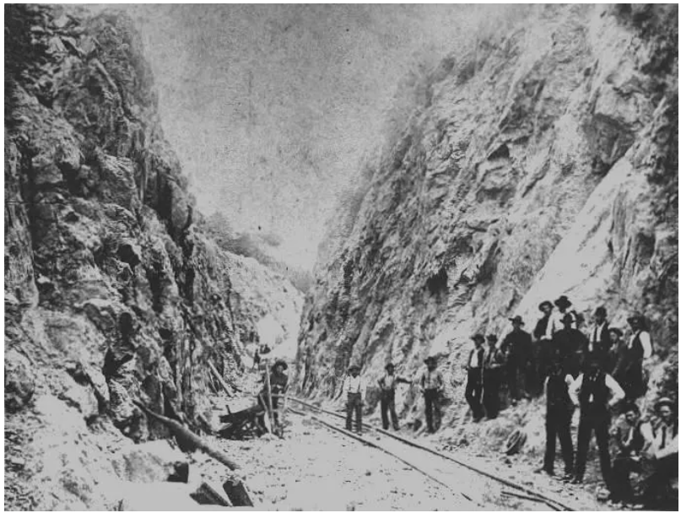
There’s an old, abandoned railroad deep in the U.P. wilderness. It was cut through a solid rock mountain in order to transport ore from the town of Champion to Skanee, approximately 30 miles northwest. It has been nicknamed “The Rock Cut” and is a trek destination for the adventurous. It is not an easy journey to accomplish, but there are a good handful of people who made the haul. But first, some info on The Rock Cut…
It was in 1890 when Detroit businessmen thought it was a good investment to throw their funds into an ore transport railroad that cut a shortcut through the mountains in Baraga County. The ore would be loaded from the Champion Mine and sent to Skanee; from there it would be loaded onto a docked freighter in the nearby skinny Huron Bay and sent to the Soo Locks, where it would be transferred.
Two million dollars and 1,500 laborers were invested in this prestigious project, cutting, dynamiting, digging, pounding through tons of solid rock – day after day, month after month, sweating, terrible living quarters, fending off bugs and hungry mosquitoes, snakes, bears, ravenous wolves, poison ivy breakouts, deaths, typhoid.
Around 1893, this slab of the Iron Range & Huron Bay Railroad was finally completed, much to the relief of the men. However, their relief turned to dismay when they learned the Champion Mine stopped producing ore, and therefore, the railroad they toiled so hard to complete WOULD NEVER BE USED.
It was then decided that the railroad would be sold. Its selling price.… $100,000. At this point most of the tracks were ripped up, and sold in lower Michigan. Parts of this track have turned into a creek, with what appear to be old ties popping through.
There were some shady dealings by the original contractors and investors, and the whole thing turned out to be one dismal cluster. However, for the curious Michigander, it is like a fantasy place out of Middle Earth. Summer is the worst time to visit, thanks to the humidity, mosquitoes, and thick underbrush. Spring is too muddy. Wintertime at the Rock Cut is absolutely breathtaking, and if you don’t mind the cold, go for it…you will love the view! Otherwise, make your visit in the fall.

